# Not showing $10 Credit for Surplus

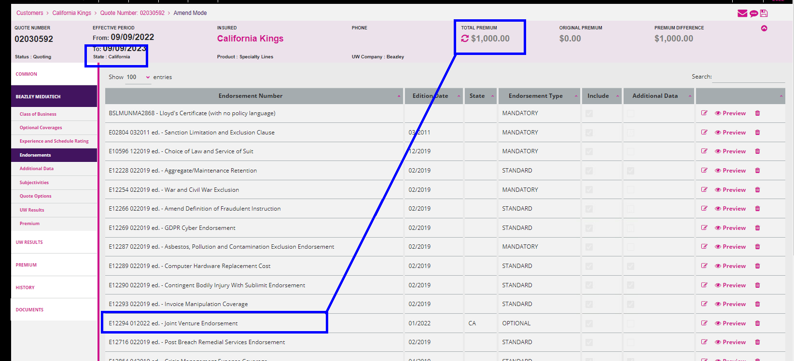

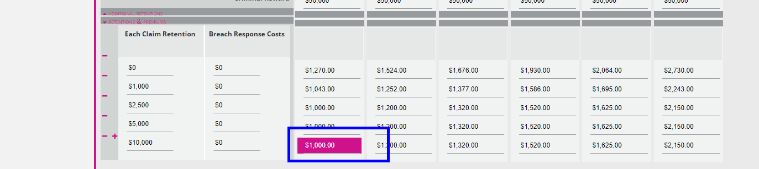

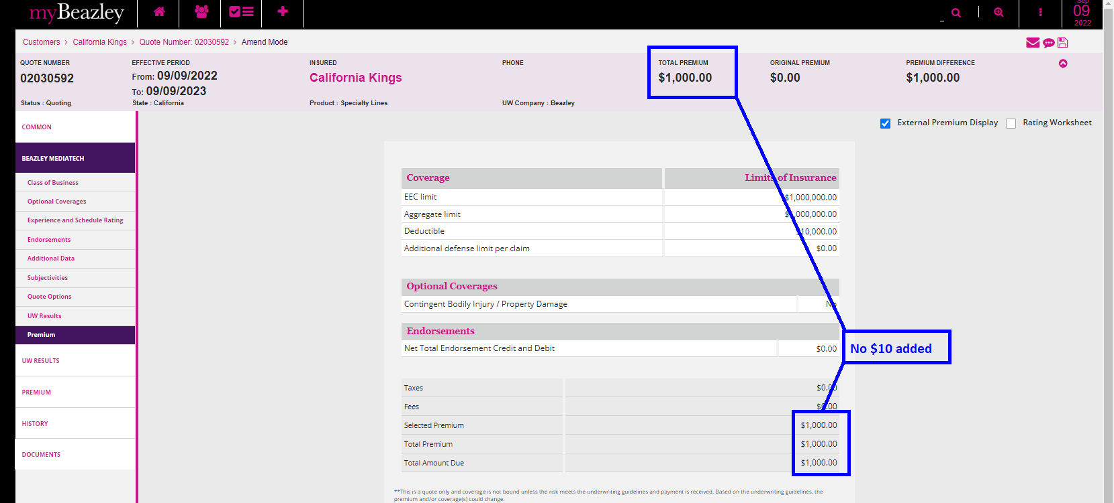

Quote Letter



